Myocardial ischaemia classification of ECG using Convolutional Neural Network

Subrata Sarkar1, Pratyusha Sinha1, Sneha Tiwari1, Madhurima Purkait1 , Bimal Pal1

1Government College of Engineering and Ceramic Technology, Kolkata, India

subrotosarkar32@gmail.com, [pratyushasinha2000@gmail.com,](mailto:subrotosarkar32@gmail.com,) [tiwarisnheha272@gmail.com,](mailto:alokmukherjee.ju@gmail.com,) [madhurimapurkait@gmail.com](mailto:partha.jumech@gmail.com), [pal_bimal@yahoo.com,](mailto:pal_bimal@yahoo.com,)

**Abstract.** With rise in sedentary lifestyle we face multiple ailments which were less common in the past. One such disease is myocardial ischaemia. Myocardial ischaemia occurs when blood flow through one or more coronary arteries decrease which in turn reduces the amount of oxygen recieved by the heart and can slowly overtime lead to serious complications.So we decided to detect this disease in early stages to help people with the diagnosis. We have created a Convolutional Neural Network (CNN) based Deep Learning (DL) model that detects myocaridial ischaemia from the V4 lead Electrocardiogram(ECG) records of patients by classifying a given ECG to help lab technicians, doctors and people with the diagnosis. In this study the CNN based DL model, a 5 layered model. We take the ECG record of the patient and run it through the model and give the prediction. We have build this model using python which can be easily deployed online as a webapp using Flask microservices framework. The python notebook is available with the project files.

**Keywords:** CNN, Deep Learning, ECG classification.

1. Introduction

Myocardial ischaemia occurs when blood flow through one or more coronary arteries decrease which in turn reduces the amount of oxygen received by the heart and can slowly overtime lead to serious complications. It requires review of a ECG by highly trained specialists and confirmation through clinical history, vital signs and laboratory exams. Myocardial ischaemia usually manifests as an area of ST segment depression or T wave flattening or inversion [1] on ECG record. In addition, clinicians are faced with reading high volumes of ECGs every shift. The Physionet is a repository of freely available medical research data and we have used the European st-t dataset (namely records e0103,e0104,e0105,e0108) provided by them for training our model.[2] Even though technology has made progress this far , still people have no way to use the available technology to increase their quality of life. So we created this CNN which can predict myocardial ischaemia with approximately over 90 % accuracy. This will enable technicians to increase their efficiency and allow patients to consult with a physician immediately if disease detection gives positive result. We have used Keras with Tensorflow backend to create our convolutional neural network. We then used open source ECG data available on Physionet to train our deep learning model. We have tried our best to build a model that is light weight but provides acceptable accuracy with high specificity so that it can deployed and used on everyday computation devices or can be handled by less powerful computers easily. We have trained our model on a limited dataset and we need to increase the input data along with variations possible in input data.

Myocardial ischaemia mainly characterized by ST segment depression and T wave flattening or inversion.

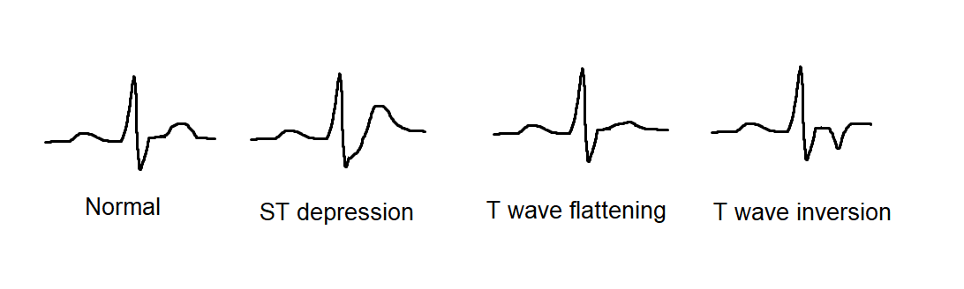

Figure 1: Various ECG waves

While there are numerous conditions that may simulate myocardial ischaemia (e.g. left ventricular hypertrophy, digoxin effect), dynamic ST segment and T wave changes (i.e. different from baseline ECG or changing over time) are strongly suggestive of myocardial ischaemia.[1]

1. Previous Work

There have been recent efforts on creating openly available ECG record databases with the studied patient numbers ranging from a few ten to one hundred. We have used ECG records provided by CNR Institute for Clinical Physiology in Pisa[3] on Physionet. “Multiclass classification of myocardial infarction with convolutional and recurrent neural networks for portable ECG devices” a paper published on ScienceDirect states how using images of ECG waves they are able to predict myocardial infraction.[4] With the recent strides in the field of deep learning with visualization of CNN using activation maximization and other techniques it is easier to evaluate and properly understand the inner workings of the neural networks . But we feel using images as input can result in input data loss and also introduces variations in input data as we feed an image. So, we feed the ECG signal directly to our model and as a result believe to see large improvement in terms of classifying accuracy as we already know CNNs specialize in identifying hidden patterns in data and classifying data pretty accurately.

1. Methodology

We have built a neural network model a shallow 5 layered network.

We slice the ECG into 240 samples each as an average heart beat is of 0.8secs and the sampling rate was 250Hz so we get 200 samples and after that we take 40 more samples so that we get almost a full hearbeat each time. Even if the heartbeat get sliced from the middle we need not look after that as long as the slices get labeled correctly because it helps us classify inputs like that. Our focus should be to train the model on correctly labeled ECG slice having as many variation as possible . This will help with classification of corner cases.

Next we describe the structure of each of the networks.

Model : This is a the 5 layered CNN model. We used dataset from European st-t dataset (namely records e0103,e0104,e0105,e0108) of physionet and sliced it to 240 samples each and then annotated the slices for training our model. We have used 80:20 split for training and testing. Here is the architecture of the model:

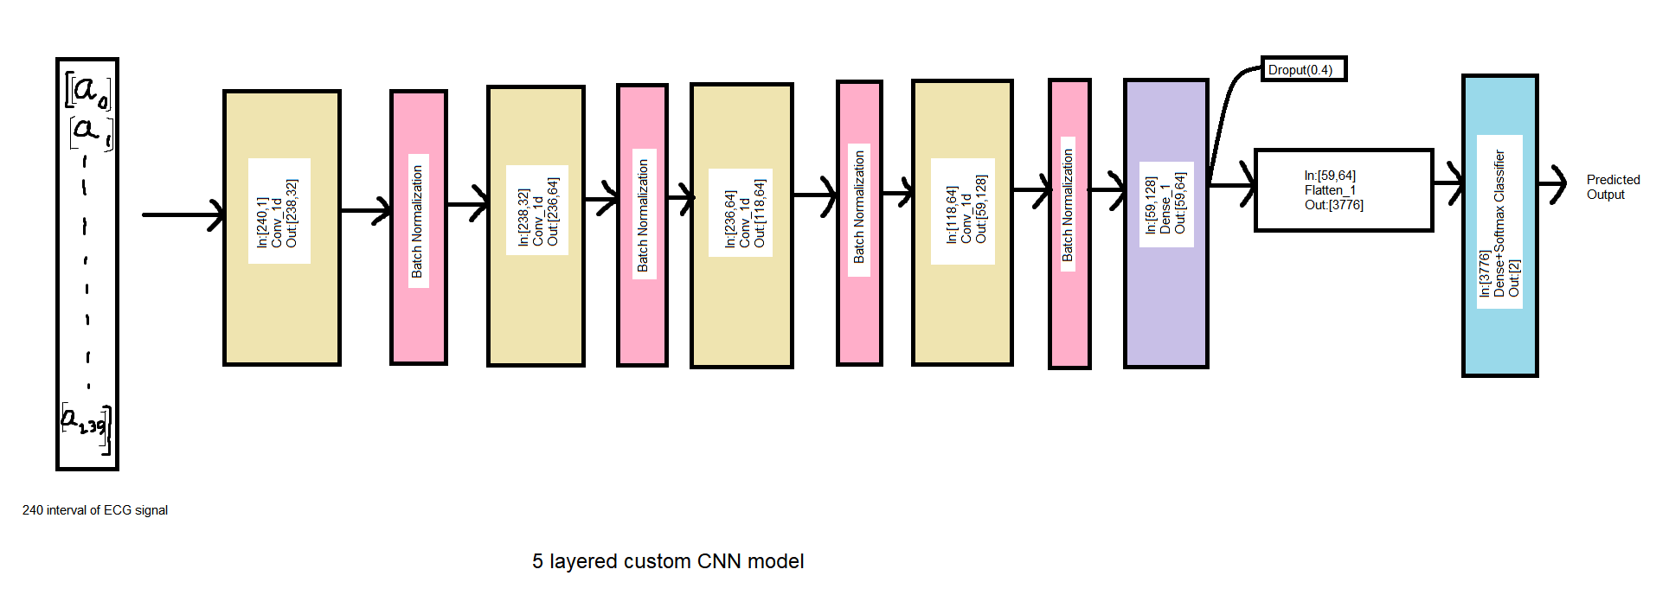

Figure 2: Custom 5 layer model

Now we find out accuracy, specificity, f1-score and MCC(Mathew’s Corelation coefficient) for the 5 layered model

Tools used:

Keras been used with tensorflow backend in python.

1. Results and Discussion

**Results for myocardial ischaemia detection:**

Here we provide the table for comparison of the models:

|  |  |  |  |  |  |
| --- | --- | --- | --- | --- | --- |
| **Models** | **Accuracy** | **Sensitivity** | **Specificity** | **F1-score** | **MCC** |
| Custom model 5 layers | 0.9104 | 0.7761 | 0.9706 | 0.8428 | 0.7864 |

Table 1: Model metrics

Next we provide the metrics for training the models and also metrics on how the models performed on test data.

For training our model we followed the below mentioned approach:

The 5 layered model has been trained for 53 epochs .

Raw ECG signal was fed alongwith the classification.

The dataset is really small and more data is needed so that the model can account for variations such as brachardyia and trachardyia.

**Custom model 5 layers:**

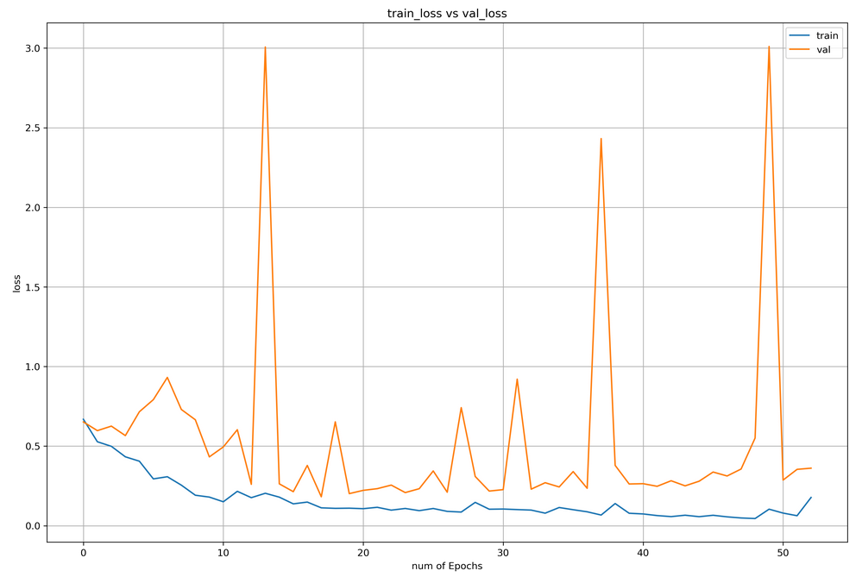

Figure 3: Train loss vs Validation loss

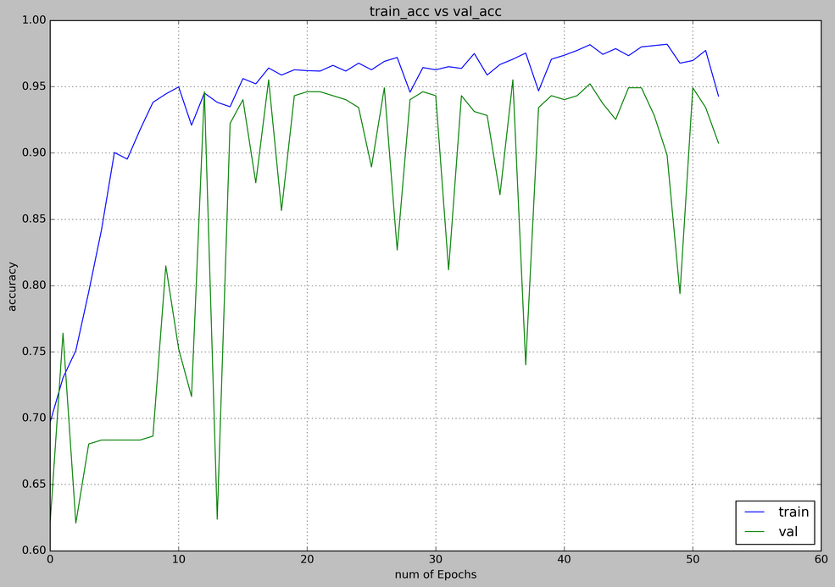

Figure 4: Train accuracy vs Validation accuracy

Test_Accuracy = 0.910394265232975

Confusion matrix, without normalization:

[[201 58]

[ 17 561]]

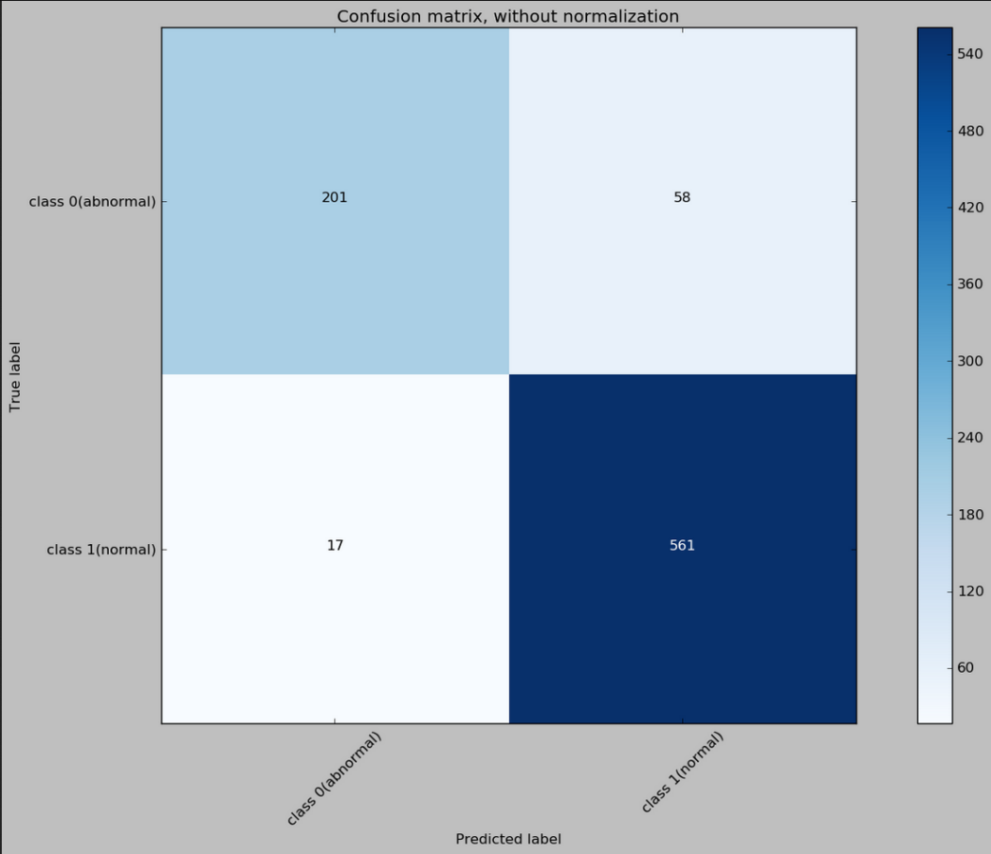

Figure 5: Confusion matrix

Example of sample run on manually generated ECG with defects:

Sample input:

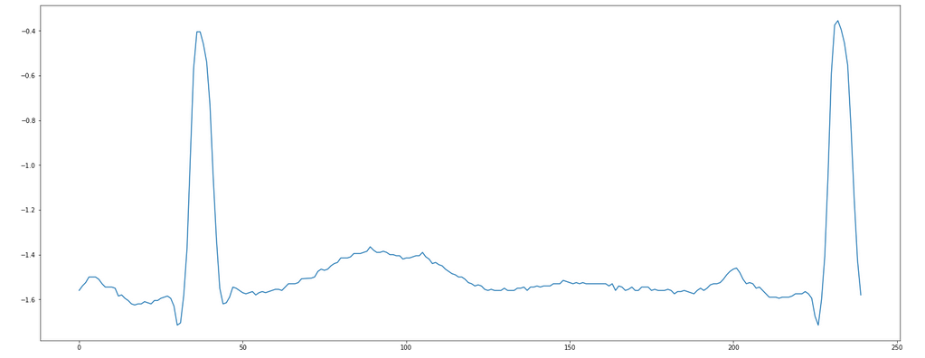

Figure 6: Sample ECG input

Real category: class 1(abnormal)

Predicted: class 1(abnormal)

1. Conclusion

From the results we can conclude that the both CNN model described here performs pretty well. Also the metrics for the test dataset prove the CNN model to be quite effective for ECG classification but more data is needed for training. The custom model has been tested for deployment using Flask locally. We hope this work will pave path for faster and efficient detection of myocardial ischaemia by the lab technicians and as a result help in faster diagnosis of patients. The model shows promising result.

# References

* 1. https://litfl.com/myocardial-ischaemia-ecg-library/
  2. https://physionet.org/content/edb/1.0.0/
  3. https://www.cnr.it/en
  4. Hin Wai lui, King Lau Chow , “Multiclass classification of myocardial infarction with convolutional and recurrent neural networks for portable ECG devices” available online at https://www.sciencedirect.com/science/article/pii/S2352914818301333